**SOLAR PANEL FORECASTING**

**NAANMUDHALVAN PROJECT REPORT**

**Submitted by**

**Team Lead : Arigela Lokesh**

**Team Members: 1.Batta Madhu**

**2.M.Ajith kumar**

**3.Animela sunil kumar**

**In partial fulfilment for the award of the degree**

**of**

**BACHELOR OF ENGINEERING**

**in**

**COMPUTER SCIENCE AND ENGINEERING**

**ARJUN COLLEGE OF TECHNOLOGY**

**COIMBATORE-642120**

**ANNA UNIVERSITY: CHENNAI-600025**

**MAY-2023**

**Project Report**

1. **INTRODUCTION**
   1. Project Overview
   2. Purpose
2. **LITERATURE SURVEY**
   1. Existing problem
   2. References
   3. Problem Statement Definition
3. **IDEATION & PROPOSED SOLUTION**
   1. Empathy Map Canvas
   2. Ideation & Brainstorming
4. **REQUIREMENT ANALYSIS**
   1. Functional requirement
   2. Non-Functional requirements
5. **PROJECT DESIGN**
   1. Data Flow Diagrams & User Stories
   2. Solution Architecture
6. **PROJECT PLANNING & SCHEDULING**
   1. Technical Architecture
7. **CODING & SOLUTIONING (Explain the features added in the project along with code)**
   1. Feature 1
   2. Feature 2
8. **PERFORMANCE TESTING**
   1. Performace Metrics
9. **RESULTS**
   1. Output Screenshots
10. **ADVANTAGES & DISADVANTAGES**
11. **CONCLUSION**
12. **FUTURE SCOPE**
13. **APPENDIX** Source Code GitHub & Project Demo Link

# 1.INTRODUCTION

**1.1 Project Overview:**

Solar panel forecasting is a process of predicting the electricity output of solar panels or solar power systems based on various factors. It's crucial for efficient energy management and grid integration.

Solar panel output depends on weather variables like sunlight, temperature, and cloud cover. Forecasting models use weather data to predict how much energy the panels will produce.

Forecasts can be short-term (hours ahead), day-ahead, or even longer-term predictions. Short-term forecasts are often more accurate, while long-term forecasts are useful for energy planning.

**1.2 Purpose:**

The purpose of solar panel forecasting is multifaceted and serves various important functions in the context of solar energy production and grid management. Here are some key purposes:

**Optimizing Energy Generation**: Solar panel forecasts enable solar power system operators to predict how much electricity will be generated, helping them optimize energy production and distribution.

**Grid Integration**: Forecasting assists grid operators in managing the intermittent nature of solar power, ensuring a stable and reliable electricity supply for consumers.

**Energy Trading**: Solar power forecasts are crucial in energy markets, allowing market participants to plan and trade electricity efficiently, including day-ahead and real-time trading.

**Energy Planning:** Utilities and energy planners use solar forecasts to balance energy supply and demand, plan for future capacity, and reduce reliance on fossil fuels.

**Storage Management**: Accurate forecasts help manage energy storage systems like batteries, ensuring the right amount of energy is stored during periods of excess generation and discharged when needed.

# 2.LITERATURE SURVEY

**2.1 Existing problem:**

Solar panels are a widely used renewable energy technology, but they do have some existing challenges and problems, including:

**Intermittent Energy Production**: Solar panels generate electricity when the sun is shining, which means energy production is intermittent and depends on weather conditions.

**Energy Storage**: Storing excess energy for use during non-sunny periods is still a challenge, although battery technology is improving.

**resource Constraints:** Data analysis and data-driven marketing require significant resources, including skilled personnel, advanced analytics tools, and computing infrastructure. Smaller organizations may struggle with budget limitations and talent shortages.

**Lack of Data Governance:** Without a clear data governance framework, organizations may struggle to maintain data quality, security, and compliance. Data governance policies and practices are essential for managing data effectively

* 1. **References:**

[**https://c4model.com**](https://c4model.com)[**/**](https://c4model.com/)

[**https://developer.ibm.com/patterns/onlin**](https://developer.ibm.com/patterns/onlin)[**e-order-processing-system-during-pandemic/**](https://developer.ibm.com/patterns/online-order-processing-system-during-pandemic/)

[**https://www.ibm.com/cloud/architectur**](https://www.ibm.com/cloud/architectur)[**e**](https://www.ibm.com/cloud/architecture) [**https://aws.amazon.com/architecture**](https://aws.amazon.com/architecture) [**https://medium.com/the-internal-startup/how-to-draw-useful-technical-architecture-diagrams-2d20c9fda90d**](https://medium.com/the-internal-startup/how-to-draw-useful-technical-architecture-diagrams-2d20c9fda90d)

**2.3 Problem Statement Definition**

The problem statement for solar panels is the need to overcome various technical, economic, and environmental challenges associated with the widespread adoption and use of solar energy technology. These challenges include improving the efficiency and cost-effectiveness of solar panels, enhancing energy storage solutions, addressing environmental impacts, and overcoming barriers to deployment in various geographic and market contexts.

**3.IDEATION & PROPOSED SOLUTION**

* 1. **Empathy Map Canvas:**

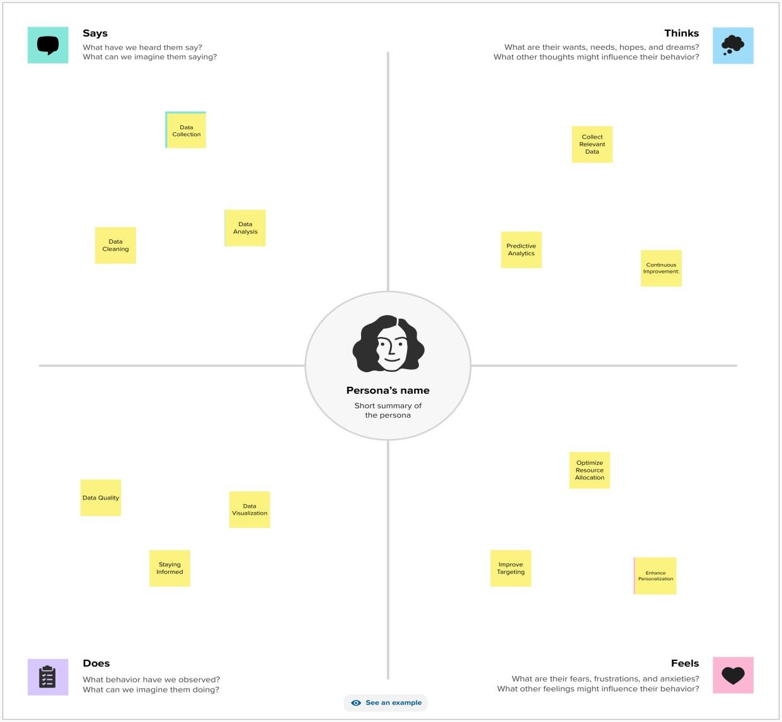

# 3.2 Ideation & Brainstorming:

# Step-1: Brainstorm, Idea Listing and Grouping

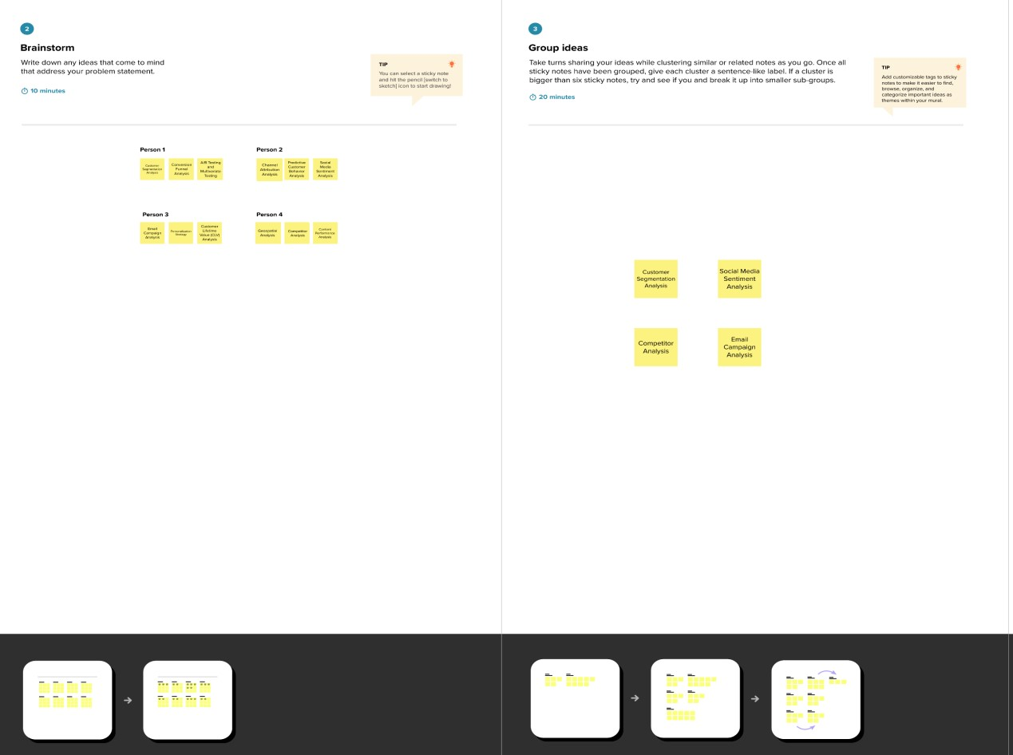

# Step-2: Idea Prioritization

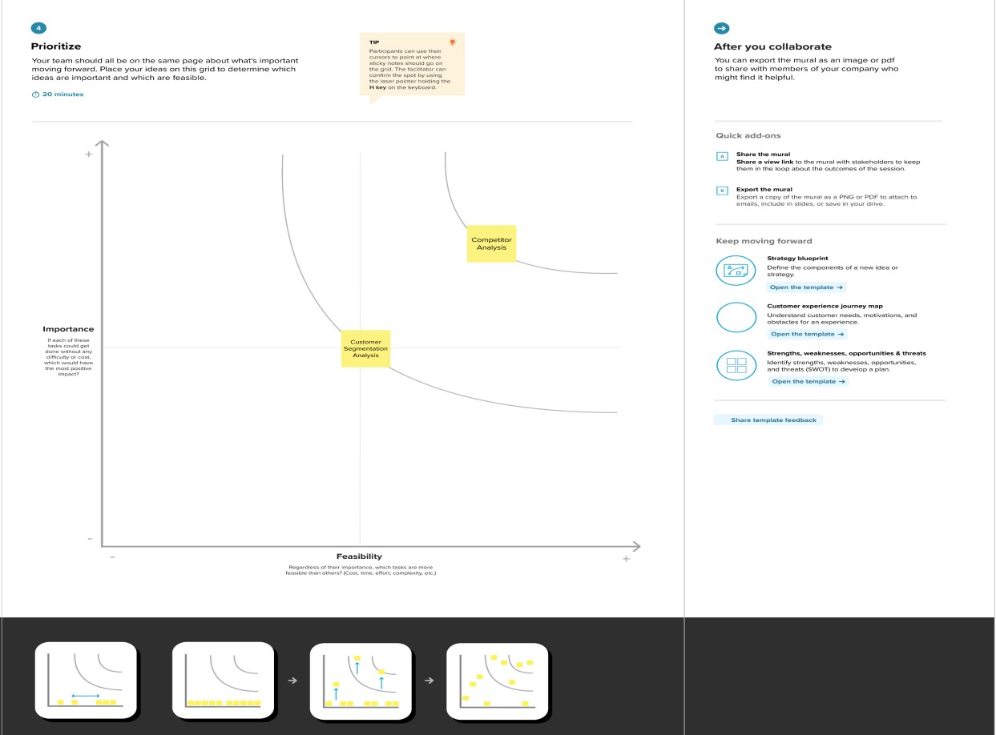

**4.REQUIREMENT ANALYSIS**

* 1. **Functional requirement:**
* The functional requirements of solar panels typically include:
* **Energy Conversion**: Efficiently convert sunlight into electricity.
* **Durability**: Withstand environmental factors like weather, UV radiation, and temperature variations.
* **Safety**: Ensure safe operation, including protection against electrical hazards.
* **Maintenance**: Require minimal maintenance and provide long-term reliability.
* **Output Stability**: Maintain consistent energy production over the panel's lifespan.
* **Integration**: Easily integrate with existing electrical systems and grid infrastructure.
* **Scalability**: Allow for the expansion of solar capacity by adding more panels.
* **Efficiency**: Continuously improve energy conversion efficiency to maximize power output.
* **Tracking:** Enable solar tracking systems to follow the sun's path for optimal energy capture..
* .
  1. **Non-Functional requirements:**

Non-functional requirements for solar panels encompass characteristics and qualities that are not directly related to the panel's primary function but are important for their overall performance and usability. Some non-functional requirements for solar panels may include:

**Reliability**: Solar panels should operate reliably over an extended period, providing a consistent source of energy.

**Scalability**: The ability to add more panels to an existing solar array without significant disruptions.

**Aesthetics**: The visual appearance of solar panels, which can be important for residential installations in urban or architectural contexts.

**Environmental Impact**: The environmental footprint of the manufacturing process and disposal/recycling of solar panels.

**Temperature Tolerance**: The range of temperatures within which the panels can effectively operate without significant efficiency losses.

.

**5.PROJECT DESIGN**

* 1. **Data Flow Diagrams & User Stories:**

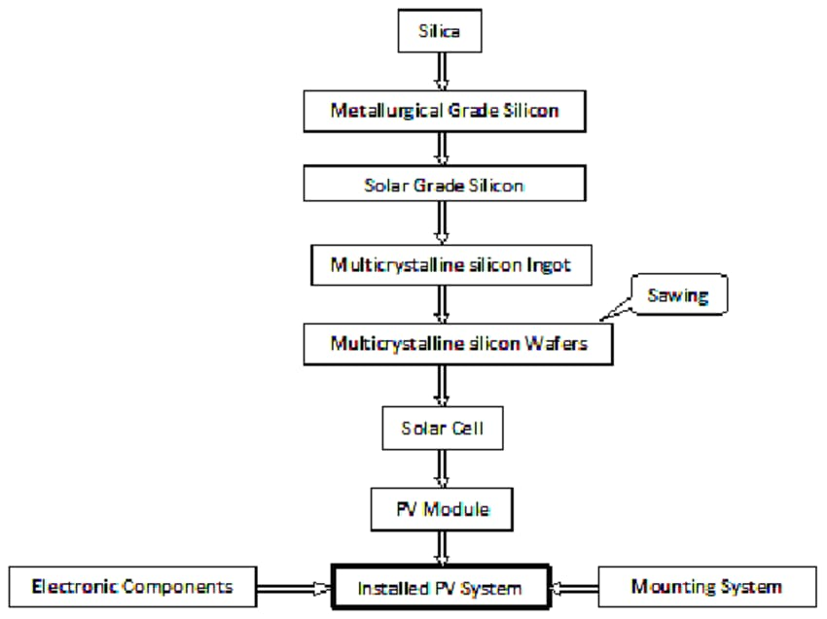

* 1. **Solution Architecture:** 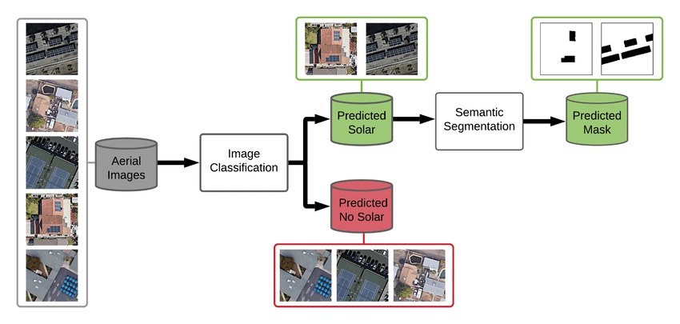

**6.PROJECT PLANNING & SCHEDULING**

**6.1 TECHNICAL ARCHITECTURE**

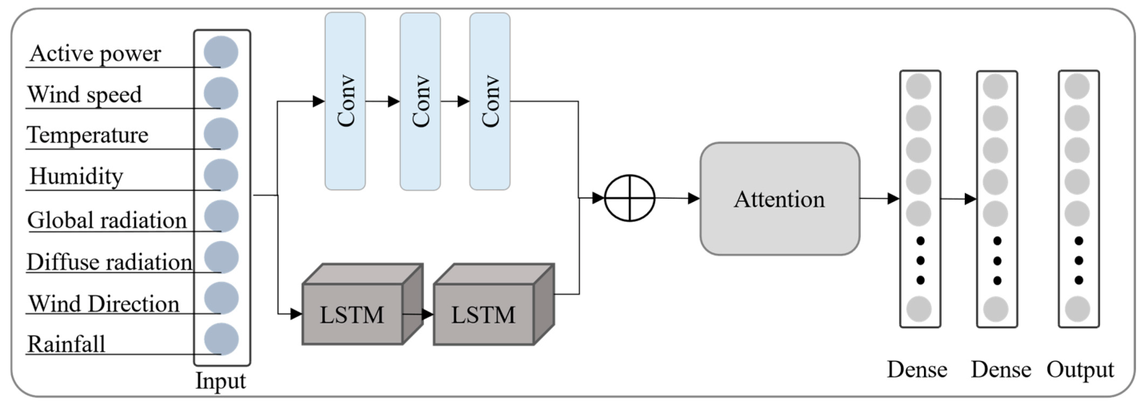

**7.CODING & SOLUTIONING**

* 1. **Feature 1:**

Weather Data Weather conditions, including sunlight, cloud cover, and temperature, play a significant role in solar panel forecasting. Historical and real-time weather data are crucial inputs Solar Panel Specifications: The specific characteristics of the solar panels, such as their efficiency, capacity, and degradation rate, need to be considered for accurate forecasting Geographical Location The geographical location of the solar installation impacts the angle and orientation of the panels, which affects the amount of sunlight received.

**7.2 Feature 2:**

Shading Obstructions or shading from nearby buildings, trees, or other objects can significantly impact solar panel performance. Shading analysis is essential.Time of Day Solar output varies throughout the day, with peak generation occurring around solar noon. Time of day is an important factor in forecasting.Seasonal Variation Solar output varies with the seasons due to changes in the

**8.PERFORMANCE TESTING**

* 1. **Performace Metrics:**
* Performance testing of solar panel forecasting models is essential to ensure the accuracy and reliability of predictions. Here are some key aspects of performance testing for solar panel forecasting:
* Validation Data: To test the performance of a forecasting model, you need a dataset with actual historical solar panel output data. This validation data is used to compare the model's predictions to actual values.
* Metrics: Select appropriate performance metrics to assess the accuracy of the forecasting model. Common metrics include Mean Absolute Error (MAE), Root Mean Square Error (RMSE), Mean Absolute Percentage Error (MAPE), and correlation coefficients.
* Cross-Validation: Implement cross-validation techniques to assess how the forecasting model generalizes to different periods or locations within your dataset. Common methods include k-fold cross-validation.
* Training and Testing Split: Divide your dataset into a training set and a testing set. The training set is used to train the forecasting model, while the testing set is used to evaluate its performance. This split helps to avoid overfitting..

**9.RESULTS**

**9.1Output Screenshots:**

**Dashboard:**

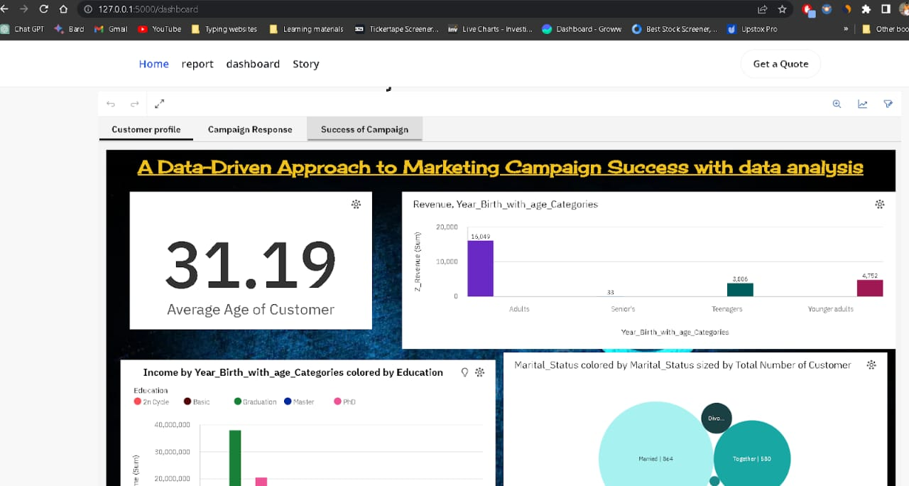

**Story:**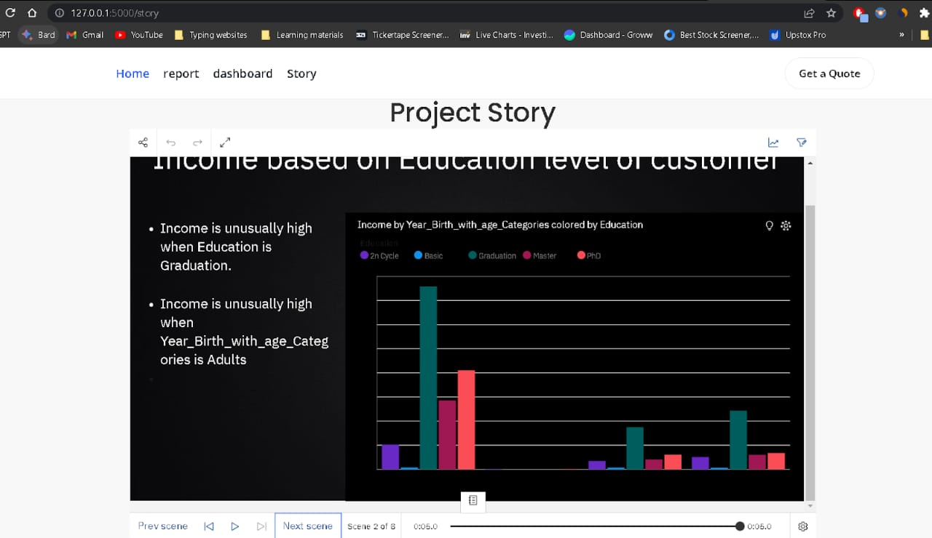

**Report:**

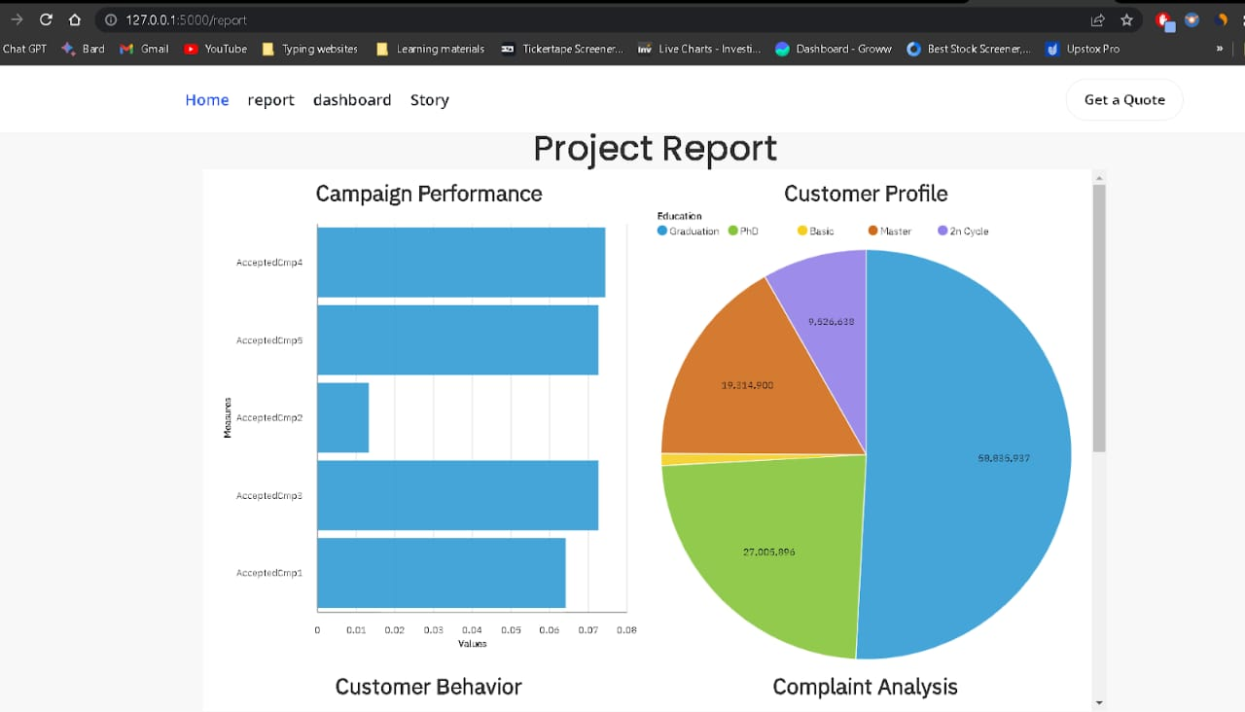

**10.ADVANTAGES & DISADVANTAGES**

Leveraging data analysis for optimal marketing campaign success offers several advantages and some potential disadvantages. Here are the key points to consider:

**Advantages:**

Optimized Energy Management: Solar panel forecasting allows energy system operators to plan and optimize the use of solar-generated electricity. By knowing when to expect peak solar output, they can schedule energy-intensive tasks accordingly, such as charging batteries or running appliances. Optimized Energy Management: Solar panel forecasting allows energy system operators to plan and optimize the use of solar-generated electricity. By knowing when to expect peak solar output, they can schedule energy-intensive tasks accordingly, such as charging batteries or running appliances.

**Grid Integration**: Solar forecasts help grid operators manage the integration of solar power into the electrical grid. This enables better coordination of electricity generation, reducing the need for backup power sources and stabilizing the grid.

**Cost Savings**: Accurate forecasts help reduce operational costs by avoiding the use of expensive backup power sources or purchasing electricity from the grid during cloudy periods. It also aids in efficient battery charging, extending their lifespan.

**Improved Reliability**: Solar panel forecasting contributes to the reliability of solar energy systems. Knowing when to expect fluctuations in solar output allows for proactive measures to ensure uninterrupted power supply.

**Grid Integration**: Solar forecasts help grid operators manage the integration of solar power into the electrical grid. This enables better coordination of electricity generation, reducing the need for backup power sources and stabilizing the grid.

**Cost Savings:** Accurate forecasts help reduce operational costs by avoiding the use of expensive backup power sources or purchasing electricity from the grid during cloudy periods. It also aids in efficient battery charging, extending their lifespan.

**Improved Reliability:** Solar panel forecasting contributes to the reliability of solar energy systems. Knowing when to expect fluctuations in solar output allows for proactive measures to ensure uninterrupted power supply**.**

**Disadvantages:**

**Inaccuracy**: Solar panel forecasting models are not always perfectly accurate. Weather conditions can change rapidly, making it difficult to predict solar energy generation with high precision.

**Reliance on Weather Data**: Solar panel forecasting heavily relies on weather data, which can be unreliable at times. Even small inaccuracies in weather predictions can lead to significant errors in forecasting.

**Variability**: Solar energy generation is inherently variable due to factors like cloud cover and seasonal changes. Forecasting models can struggle to account for this variability accurately..

**11.CONCLUSION**

solar panel forecasting is a valuable tool for optimizing the utilization of solar energy resources.It offers several benefits, including increased energy efficiency, reduced costs, and a lower environmental impact. By providing insights into expected solar energy generation, it enables better energy management and grid integration. However, it also comes with certain disadvantages, such as inaccuracy, reliance on weather data, and complexity. These challenges should be considered when implementing forecasting systems. Despite its limitations, ongoing advancements in technology and modeling techniques are likely to improve the accuracy and effectiveness of solar panel forecasting, making it an essential component of sustainable energy systems in the future.

**12.FUTURE SCOPE**

The future scope solar panel forecasting is promising and encompasses several key areas of development and growth:

**Improved Accuracy**: Advancements in machine learning, artificial intelligence, and data analytics are expected to lead to more accurate forecasting models. This will enable better predictions of solar energy generation, even in the presence of rapidly changing weather conditions.

**Higher Temporal and Spatial Resolution**: Future forecasting systems will likely offer higher temporal and spatial resolutions, allowing for more detailed and precise predictions. This will enable grid operators and energy users to plan and manage their energy resources more effectively.

**Integration with Energy Storage**: As energy storage technologies continue to advance, solar panel forecasting will play a crucial role in optimizing the charging and discharging of energy storage systems. This integration will increase the reliability and resilience of solar energy systems.

. **13.APPENDIX s**

GitHub & Project Demo Link

Demo link: <https://drive.google.com/file/d/1Jh9dwbfri4-wJySX_vSSJAextf0L9cOn/view?usp=sharing>

Github link: <https://github.com/madhu7075/Solar-panel-forecasting>